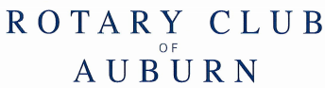

June 2, 2021

Rotary Supporter
123 Main Street
Auburn, CA 95603

Dear Rotary Supporter,
The Auburn Rotary Club would like to thank you again for your continued support, especially with your sponsorship of the Spirit of Auburn Community BBQ in the past. The event this year is on Saturday, September 19, 2021 from 4:30 – 7:30 pm. In consideration of COVID-19 protocols, we will provide a drive through dinner including chicken, pork ribs, baked beans, coleslaw, a Hawaiian roll and a cookie. The location of the event will be at the Boys & Girls Club of Placer County located at 679 Lincoln Way, Auburn.
We appreciate your $100 sponsorship of our 2019 event.
Your support and the proceeds of this event go right back into the wonderful Auburn community in the form of Placer High School scholarships, Acres of Hope, Boys & Girls Club of Placer County, Peace for Families and much more.
Please find attached the sponsorship form with the various levels of sponsorships available. We would be honored to have your support again this year!
Please feel free to contact me with any questions.
THANK YOU in advance for your support!

Rodney Borges
Auburn Rotary Club
530.277.7835

